Customer Journey Map:
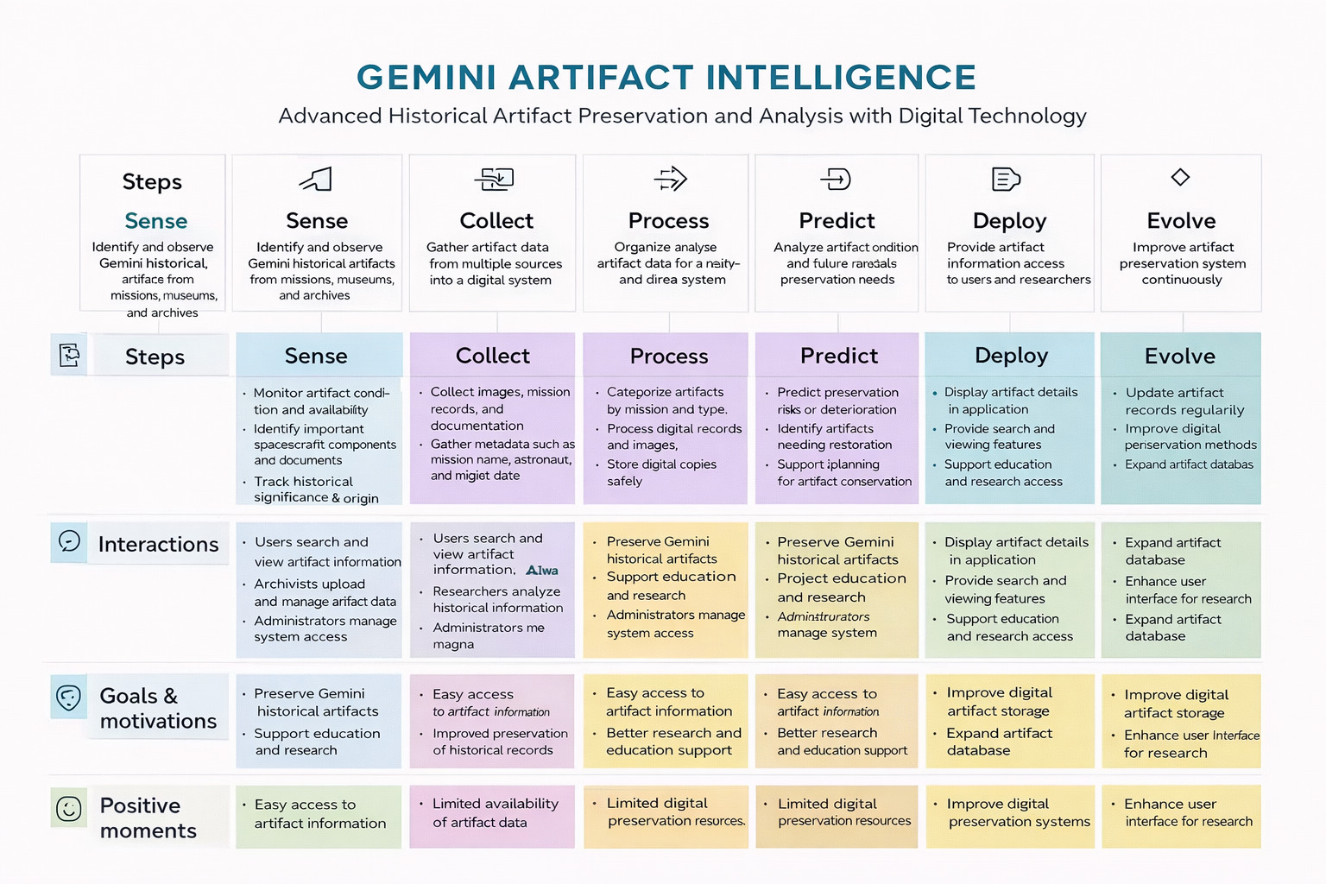

🧠 Customer Journey for Gemini historical artifact description
Advanced Historical Artifact Preservation and Analysis with Digital Technology

Steps:

1.Sense
Identify and observe Gemini historical artifacts from missions, museums, and archives.
- Monitor artifact condition and availability
- Identify important spacecraft components and documents
- Track historical significance and origin

2.Collect
Gather artifact data from multiple sources into a digital system.
- Collect images, mission records, and documentation
- Gather metadata such as mission name, astronaut, and data.
- Gather metadata such as documentation

3.Process
Organize and analyze artifact data for preservation and research.
- Categorize artifacts by mission and type
- Process digital records and images
- Ensure data accuracy and completeness

4.Predict
Analyze artifact condition and future preservation needs.
- Predict preservation risks or deterioration
- Identify artifacts needing restoration
- Support planning for artifact conservation

5.Deploy
Provide artifact information access to users and researchers.
- Display artifact details in application
- Provide search and viewing features
- Support education and research access

6.Evolve
Improve artifact preservation system continuously.
- Update artifact records regularly
- Improve digital preservation methods
- Expand artifact database

7.Interactions
- Users search and view artifact information
- Archivists upload and manage artifact data
- Researchers analyze historical information
- Administrators manage system access

8.Goals & Motivations
- Preserve Gemini historical artifacts
- Support education and research
- Protect space exploration heritage
- Provide digital access to artifact information

9.Positive Moments
- Easy access to artifact information
- Improved preservation of historical records
- Better research and education support
- Increased awareness of space history

10.Negative Moments
- Limited availability of artifact data
- Risk of artifact damage or deterioration
- Incomplete documentation
- Limited digital preservation resources

11.Areas of Opportunity
- Improve digital artifact storage systems
- Expand artifact database
- Enhance user interface for research
- Increase accessibility for students and researchers

